***Project synopsis report on***

**“Detection and Inpainting of Specular Reflection in Colposcopic Images”**



*Submitted by*

Ankit Kumar Gupta, 202216061, BCA 6th Sem, Dept. of CA, ankit_202216061@smit.smu.edu.in.

Ayush Baral, 202216066, BCA 6th Sem, Dept. of CA, [ayush_202216066@smit.smu.edu](mailto:ayush_202216066@smit.smu.edu).in

Nishank Uprety, 202216065, BCA 6th Sem, Dept. of CA, [nishank_202216065@smit.smu.edu.in](mailto:nishank_202216065@smit.smu.edu.in).

Sapikcha Rai, 202216002, BCA 6th Sem, Dept. of CA, sapiksha_202216002@smit.smu.edu.in.



*Under the Supervision of*

Ms. Parimala Tamang, Assistant professor, Dept. of CA, SMIT

Name & Signature of Members Signature of Guide

1

***Abstract*:** Specular reflections are considered as an artifacts which may reduce the performance of image processing techniques. The specular reflection appears as white area on the cervical images that covers certain region of the images which affects the quality of the cervical images causing difficulty for the physician to analyse the colposcopy images.

In this project, we will detect and inpaint specular reflection regions from the colposcopy images. To do this we will implement traditional medical imaging techniques and machine learning techniques especially for colposcopy images.

***Keywords*: cervical cancer, colposcopic image, specular reflection, inpainting**

2

1. **Introduction**

Cervical cancer is a type of cancer found in the lower part of the uterus. It is the fourth most common cancer in women worldwide. It can be detected using a procedure called colposcopy, which uses a device called a colposcope to look for abnormal cells.

Specular reflection (SR) refers to white bright pixels caused by device light reflection on the captured cervical images [1]. SR degrades image quality which might affect further image analysis steps. Therefore, it must be detected and inpainted to restore image quality and ensure accurate analysis. Specular reflections raise challenging problems in medical image analysis, as it degrades (partially or entirely) the information in the affected pixels, which can lead to misdiagnosis. Therefore, it is essential to implement effective methods to address SRs and minimize its impact on colposcopic image analysis.

1. **Aim and Objective**

* **Aim**
* To develop an efficient approach for detecting and inpainting specular reflections in colposcopic images thus to enhance image clarity and improve diagnostic accuracy.
* **Objective**
* To design and implement approach to accurately detect specular reflection regions in colposcopic images.
* To implement a machine learning-based approach for image inpainting to reconstruct reflection-affected areas while preserving anatomical structure and texture.
* To compare the system's output with state-of-the-art techniques.
* To evaluate the Performance of model.

1. **General overview of the problem**

* Specular Reflection (SR) refers to bright spots in images caused by light reflection.
* These spots appear as white areas in the image and can block important details.
* SR lowers the image quality, making it harder to analyse key regions.

3

1. **Feasibility Study**

**4.1 Economical feasibility**  
Financially, it is cost-effective as it utilizes open-source libraries and software. The project is operationally viable, addressing a critical need to improve diagnostic accuracy in medical imaging.

**4.2 Technical feasibility**This project is possible because it uses reliable machine learning methods for finding and fixing bright spots in images. Tools like neural networks are available, and datasets for testing are also accessible.

**4.3 Operational feasibility**This project is practical to implement because it can be integrated into existing systems, and the required resources, like software and hardware, are easily available. Users can easily adopt the technique with minimal training.

1. **Literature Survey**

4

5

**Table 1.Literature survey**

|  |  |  |  |  |
| --- | --- | --- | --- | --- |
| **Sl.no** | **Title** | **Methodology** | **Research gap** | **Relevance** |
| **1.** | Automatic Detection and Inpainting of Specular Reflections for Colposcopic Images [1]  **(2011)** | Combined a reflection model with a technique to fill in missing image parts. | May not work well on all types of cervical images, especially those with varied lighting and colors. | Dichromatic Reflection Model |
| **2.** | Detection and Inpainting of Specular Reflection in Colposcopic Images.[2]  **(2019)** | Used a method to detect and fill in bright areas in cervical images. | Ineffective for brighter regions with complex tissues. | Exemplar-based Method |
| **3.** | Specular Reflections Removal in Colposcopic Images Based on Neural Networks:Supervised training with no ground truth previous knowledge [3]  **(2021)** | Applied neural networks to identify and remove bright spots without prior knowledge. | May require more training to retain underlying anatomical structure. | Proposed method may be used to estimate the unobserved anatomical cervix portion under the bright zones |
| **4.** | Elimination of Specular Reflection and Identification of ROI in Digital Colposcopy.[4]  **(2011)** | Developed a technique to remove bright spots and focus on relevant image areas. | Proposedmethod may not effectively handle images with uneven lighting or those taken from different angles. | Laplace’s equation. |
| **5.** | Specular Reflection Analysis and Image Denoising in Cervix Images.[5]  **(2023)** | Analyzed and reduced bright spots to enhance image quality. | Proposed technique uses a fixed brightness threshold to identify bright spots, which might not work well for all images due to differences in lighting and camera settings. | Threshold and gradient calculation. |

5

1. **Problem Definition**

* Specular reflections caused by light reflection on moist tissue surfaces obscure important details in colposcopic images, making it difficult for clinicians to assess the cervix accurately.
* Reflections lead to image distortion, reducing the overall quality and reliability of the images used for diagnosis and automated analysis.
* Reconstructing the affected areas without distorting surrounding tissue structures is a complex task, requiring advanced inpainting algorithms that preserve anatomical structure.

1. **Proposed Solution Strategy**

* Implement image pre-processing techniques focused to accurately identify and locate specular reflections regions in colposcopic images.
* Implement inpainting techniques, such as machine learning-based models to seamlessly reconstruct the areas affected by reflections, retaining the underlying structure of the cervix.
* Evaluating model’s performance using performance metrics.

4

1. **Project Plan**
   1. **Team Structure**

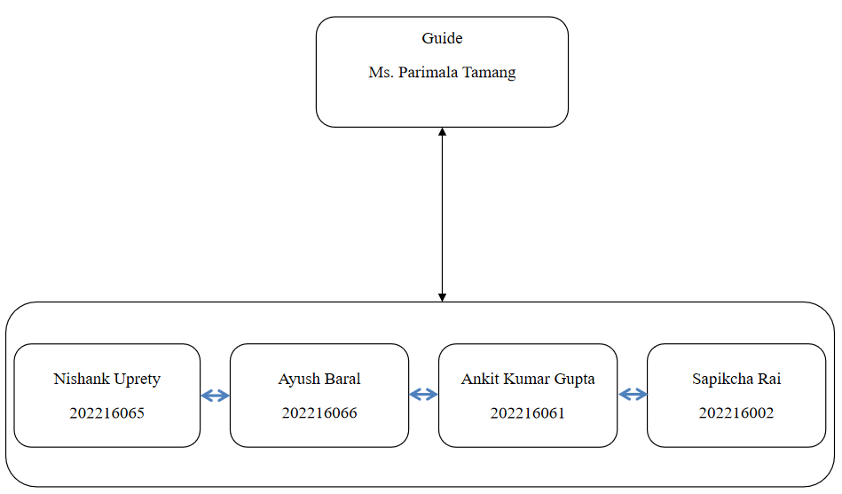

6

**Figure 1. Team structure**

* 1. **Gantt Chart(Project Schedule)**

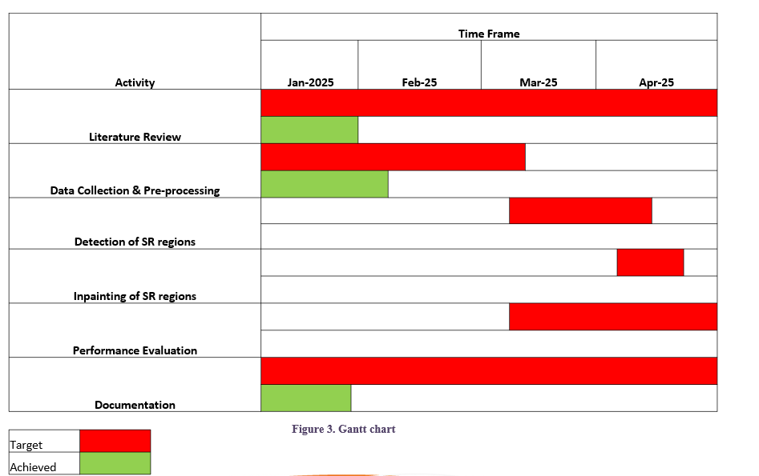



* 1. **Hardware and Software Requirement Specifications**

#### Hardware Requirements:

* **Processor:** Intel Core i5/i7 or equivalent
* **RAM:** Minimum 8 GB (16 GB recommended)
* **GPU:** NVIDIA GPU with CUDA support
* **Storage:** 256 GB SSD or more (for datasets and model storage)

#### Software Requirements:

* **Operating System:** Windows 10/11
* **Programming Language:** Python 3.x
* **Libraries/Frameworks:** TensorFlow, PyTorch, OpenCV, NumPy, Matplotlib
* **Tools:** Jupyter Notebook, Anaconda, Visual Studio Code

7

1. **Conclusion**

This project aims to address the challenge of specular reflection (SR) in colposcopic images, which can hinder image quality and diagnostic accuracy. By detecting and removing SR regions and applying machine learning-based inpainting techniques, the affected areas are restored to ensure clear and accurate images. The proposed solution is feasible, leveraging advanced algorithms and accessible resources, and has the potential to significantly enhance medical image analysis and support better clinical outcomes.

**10. References**

[1] El Meslouhi, Othmane, et al. "Automatic detection and inpainting of specular reflections for colposcopic images." Central European Journal of Computer Science 1 (2011): 341-354.

[2] Wang, Xiaoxia, et al. "Detection and inpainting of specular reflection in colposcopic images with exemplar-based method." 2019 IEEE 13th International Conference on Anti-counterfeiting, Security, and Identification (ASID). IEEE, 2019.

[3] Wang, X., Li, P., Lv, Y., Xue, H., Xu, T., Du, Y. and Liu, P., 2021. Integration of global and local features for specular reflection inpainting in colposcopic images. Journal of Healthcare Engineering, 2021(1), p.5401308.

[4] Jimenez-Martin, L., Pérez, D.A.V., Asteasuainzarra, A.M.S., Leonard, L. and Díaz-Romañach, M.L.B., 2021. Specular reflections removal in colposcopic images based on neural networks: Supervised training with no ground truth previous knowledge. arXiv preprint arXiv:2106.02221.

[5] Mukku, L. and Thomas, J., 2023, April. A Specular Reflection Removal Technique. In 2023 IEEE International Conference on Contemporary Computing and Communications (InC4) (Vol. 1, pp. 1-5). IEEE.

8